http://del.icio.us/PrestonGSC
Searching hints
You can use the search box on the top right hand corner of most Del.icio.us pages to find what you are looking for within PGSC’s bookmarks, all of del.icio.us’s bookmarks or all of the web. Here are some details about how it works:

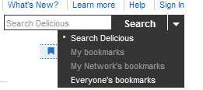

Enter some words and you will get back links that contain all of them.
The search engine goes through bookmark descriptions, notes and tags to find links for you. Tags can be searched exclusively by prefixing the word with ‘tag’ for example tag:philosophy
The search engine also supports AND and NOT.
The current tags used in our Del.icio.us page are:
